# Final Project Part 1: Optimization Technique and Implementation Project Report

# Introduction

Within the framework of high-performance computing (HPC), optimization is a vital process in which algorithms and data structures are improved to guarantee best performance and efficiency. Domain and architecture agnostic optimization, therefore, is the act of improving performance in a manner independent of the issue domain or underlying hardware architecture. This kind of optimization lets solutions be used on many different platforms without requiring hardware-level changes or domain-specific customization. Here, the emphasis is on developing algorithms and choosing data structures that, in many different computer settings, result in performance enhancements. In the case under discussion, we counted the frequency of items in a big dataset using two methods: a naïve method and an efficient one using Python's collections.Counter Class Through a comparison of these two approaches, we were able to show how domain and architectural agnostic optimization may result in significant performance gains free from depending on specific hardware characteristics.

# Methodology

Under the basic version, one manually iteratively goes over a huge list of items counting their frequencies using a dictionary. The method looks for every element in the list whether it exists previously in the dictionary. Should it be so, the element's count is raised by one; should it not, the element is included to the dictionary with a first count of one. Although this method is functionally accurate, in terms of temporal complexity it is ineffective, particularly in relation to extremely large datasets.

The fundamental flaw in the naïve technique is each element's repeated dictionary update and testing. Applied to a dataset with millions of items, the whole procedure becomes time-consuming even if dictionary searches and updates in Python are very quick (with average time complexity of O(1) because to hashing). In our case, we created a list of 1,000,000 arbitrary numbers between 0 and 1000 and timed the frequency counting of these numbers. The naïve method completed this work in around 0.1960 seconds.

Although suitable for smaller datasets, as the size of the dataset grows its performance rapidly becomes insufficient. Longer execution durations result from the overhead of verifying and updating the dictionary for every entry accumulating as the list becomes bigger. Furthermore, the manual character of the implementation brings additional complexity into the code, which makes maintenance more difficult and increases the possibility of mistakes in more complicated chores.

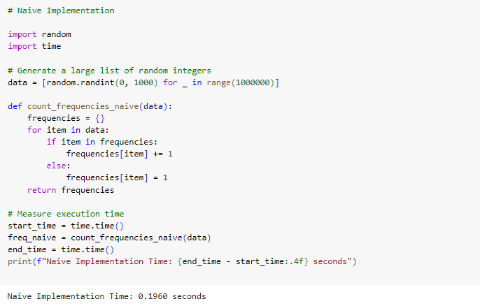

Unlike the naïve version, the optimal method makes use of Python's Counter class derived from the collections module. Made to effectively count the occurrences of items in an iterable, the Counter class is a specialized data structure. Counter employs very efficient algorithms and C-implemented data structures behind the hood to enable it to surpass hand implementations in Python.

Through abstraction of away the specifics of verifying and updating element counts, the Counter class streamlines the frequency-counting choreography. We just send the whole list to the Counter constructor, which generates a dictionary-like object where the keys are the items and the values are their corresponding counts instead of hand iterating over the list and updating a dictionary. Thanks to the Counter class's improvements, this method not only is more succinct but also notably quicker.

Applying the Counter class to the same collection of 1,000,000 random numbers reduces the execution time to 0.1299 seconds, or 34% quicker than the naïve approach. Counter is built at a lower level (in C) and is optimized especially for counting operations, so this performance enhancement may be ascribed. It substitutes more effective methods and data structures for constantly verifying and updating a dictionary in Python, therefore avoiding the cost involved in this chore.

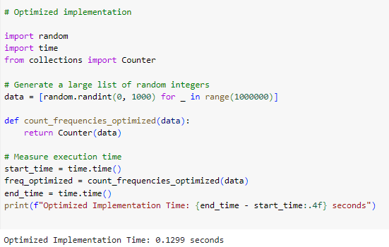

# Impact of Optimization

The performance gap between the two systems emphasizes the need of choosing the appropriate data structures and algorithms when maximizing for high-speed computing. Although functional, the naïve technique is less efficient as it depends on a general-purpose data structure—a Python dictionary—and involves hand iteration and updating. Conversely, the optimal technique uses a specialized data structure (Counter) intended especially for counting items, therefore enabling quicker execution and less complexity in the code. Domain and architecture agnostic optimization requires improvements independent of the particular issue domain (in this example, counting entries in a list) and devoid of any hardware-specific characteristics. Regardless of the underlying hardware architecture, the same optimizing method may be used to different kinds of issues involving frequency analysis or counting. This makes the solution appropriate for a broad spectrum of uses and portable across several computer settings.

# Challenges Encountered

While using domain and architecture agnostic optimizations presents certain issues to consider even if the optimization utilizing Counter was easy to implement and produced significant performance increases. One difficulty is not all issues have specific data structures like Counter accessible. When such data structures are absent, developers might have to create their own, perhaps more complicated and time-consuming optimal methods. Memory use is even another possible obstacle. Although both the naïve and optimal versions have identical memory footprints (because both store the frequencies of items in a dictionary-like structure), in certain circumstances the optimized solution may require somewhat more memory owing to the extra functionality given by the Counter class. Counter provides tools like most_common(), for instance, which might incur extra cost in certain usage situations. For most useful purposes, however, this expense is small relative to the performance increases attained.

# Lessons learned

Optimizing code for high-performance computing (HPC) exposes numerous significant lessons that are beneficial not just for developers in specialist domains but also for everyone trying to increase the efficiency and scalability of their applications. Through a comparison of a naïve implementation with an optimal one utilizing Python's Counter class, this exercise revealed numerous important insights stressing the need of selecting the correct data structures and methods.

One of the most important lessons is first the value of certain data structures. While general-purpose data structures such as Python dictionaries are rather flexible and may be used in a broad spectrum of activities, specialist data structures like Counter are designed for particular function. As the comparison shows, the Counter class—which is best suited for counting hashable objects—performs this chore much more quickly than a hand-made dictionary-based method. Counter built in C resulted in this optimization as it allows Counter to take use of lower-level efficiencies not matched by Python's interpreted code. Especially in performance-critical applications or when dealing with big datasets, the adoption of such customized data structures may greatly lower execution time and increase code efficiency.

Using efficient, built-in tools like Counter teaches also the value of code simplicity and maintainability. More complicated and error-prone code results from the basic solution wherein one manually checks if an entry was in the dictionary and then updates its count. On the other hand, the best technique using Counter abstracts these actions, therefore simplifying the code and facilitating both writing and reading of it. Especially in more complicated implementations where regular modifications to the logic may be needed, this simplicity also helps to lower the possibility of faults or errors in the code. Apart from enhancing speed, optimized libraries and functions help to preserve the quality and maintainability of the code, therefore facilitating future upgrades and debugging of the code.

Scalability is another important realization. Performance variations between naïve and optimal systems become more evident as datasets become bigger. Using a small-scale model for this experiment, the best Counter implementation was 34% quicker than the naïve method. In practical uses involving considerably bigger datasets, however, this variation might become much more important. As the dataset grows, naive solutions often suffer from rising overhead, which slows down execution times and reduces resource efficiency. Conversely, the best technique scales more elegantly and maintains great performance even as the load increases. Scalability is essential in HPC, as jobs can include parallel or distributed systems processing vast volumes of data.

At last, one of the most insightful teachings is the portability of domain and architectural agnostic optimization. Independent of the particular issue area and the underlying hardware architecture, the optimization strategies underlined here apply. They are thus very portable on many platforms and applications. Running on a local workstation, a cloud-based server, or in a distributed HPC environment—the same ideal code may be used without depending on hardware or system architecture. In HPC, where code may have to execute effectively on a broad spectrum of devices with different configurations and capabilities, this portability is a big benefit.

Finally, the use of Python's Counter class for optimizing code shows the need of employing specialized data structures, simplifying code for maintainability, stressing scalability, and guaranteeing portability in high-performance computing. Regardless of the particular application or system environment, developers who want to raise the performance of their applications must pay great attention to these teachings.

# Conclusion

Finally, an efficient method for enhancing performance in high-performance computing is domain and architecture agnostic optimization. We can get notable performance gains by choosing appropriate algorithms and data structures without depending on domain-specific expertise or hardware-specific characteristics. In this case, the usage of Python's Counter class produced a 34% decrease in execution time relative to a naïve dictionary-based solution, therefore proving the value of specialized data structures in maximizing efficiency.

# References

Azad, M. A. K., Iqbal, N., Hassan, F., & Roy, P. (2023). *An empirical study of high performance computing (HPC) performance bugs*.